

|  |  |  |  |
| --- | --- | --- | --- |
| **Student’s name** |  | **Grade** | **6** |
| **Subject** | **Computer** | **Week No.** | **2** |
| **Lesson Title** | **Pictograms** | **1st Semester Work sheet No.** | **2** |

**Instruction: Identify the meaning of the following signs**

1. 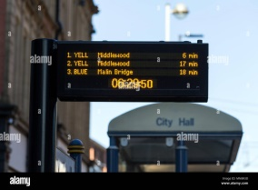 **2.** 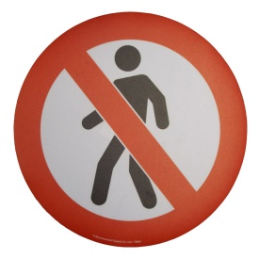

**_____________________________ _____________________**

**3.  4. **

**________________________ ______________________**

**5. **

**________________________**

**Good Luck**